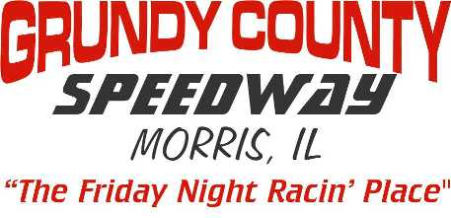
2024 Pit Pad Rental Agreement
Make Check Payable to: Grundy County Speedway

CAR # ________ DIVISION: Late Model $150 Sportsman $150 Street Stock $150
(Open spots filled in by waiting list)

Driver Name__________________________________________________

Phone #_________________________________________________

E-MAIL_______________________________________________________

( ) Area 1 North to South – (Main Row) Pads 1- 39

( ) Area 2 East to West – (Tire / Gas Sales Row) Pads 56 – 41 (46 & 47 Gas/Tires)

( ) Area 3 (Concession Row) Pads 57- 61

PIT PAD AGREEMENT
I understand this pad may not be shared, leased or given to any other competitor during the season on nights I’m not there. If I am not racing the pad can be reassigned by the track. Only park the car (division) you registered the pad with. During non Grundy County Speedway promoted events or non point nights you may be moved to a different spot. Pure Stocks & Street Stocks may be moved off pads as needed in extreme situations. Pads need to be paid in full by May 17th, 2024. If arrangements for payment are not made, fee will be deducted from earnings. After that date, any pads not paid for will be considered open and we will fill these spots based off of our waiting list. All agreements with former promoters and management are null and void effective January 1, 2013.

Sign Here - _________________________________________
( ) Same Pad I Had Last Year
( ) First Available - Mark Area Requested Above

Office Use - Paid Cash( ) Paid Check( ) Check #__________ Amount $___________

Pad # Assigned________________

